Objectives

- Explain various ways of conditional rendering
- Explain how to render multiple components
- Define list component
- Explain about keys in React applications
- Explain how to extract components with keys
- Explain React Map, map() function

In this hands-on lab, you will learn how to:
- Implement conditional rendering in React applications

Prerequisites

The following is required to complete this hands-on lab:
- Node.js
- NPM
- Visual Studio Code

Notes

Estimated time to complete this lab: 60 minutes.
Create a React App named “bloggerapp” in with 3 components.

- Book Details
- Blog Details
- Course Details

Implement this with as many ways possible of Conditional Rendering.
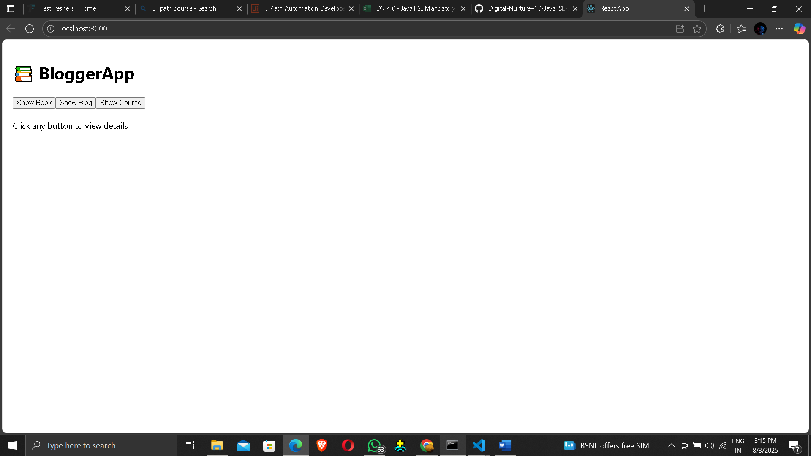
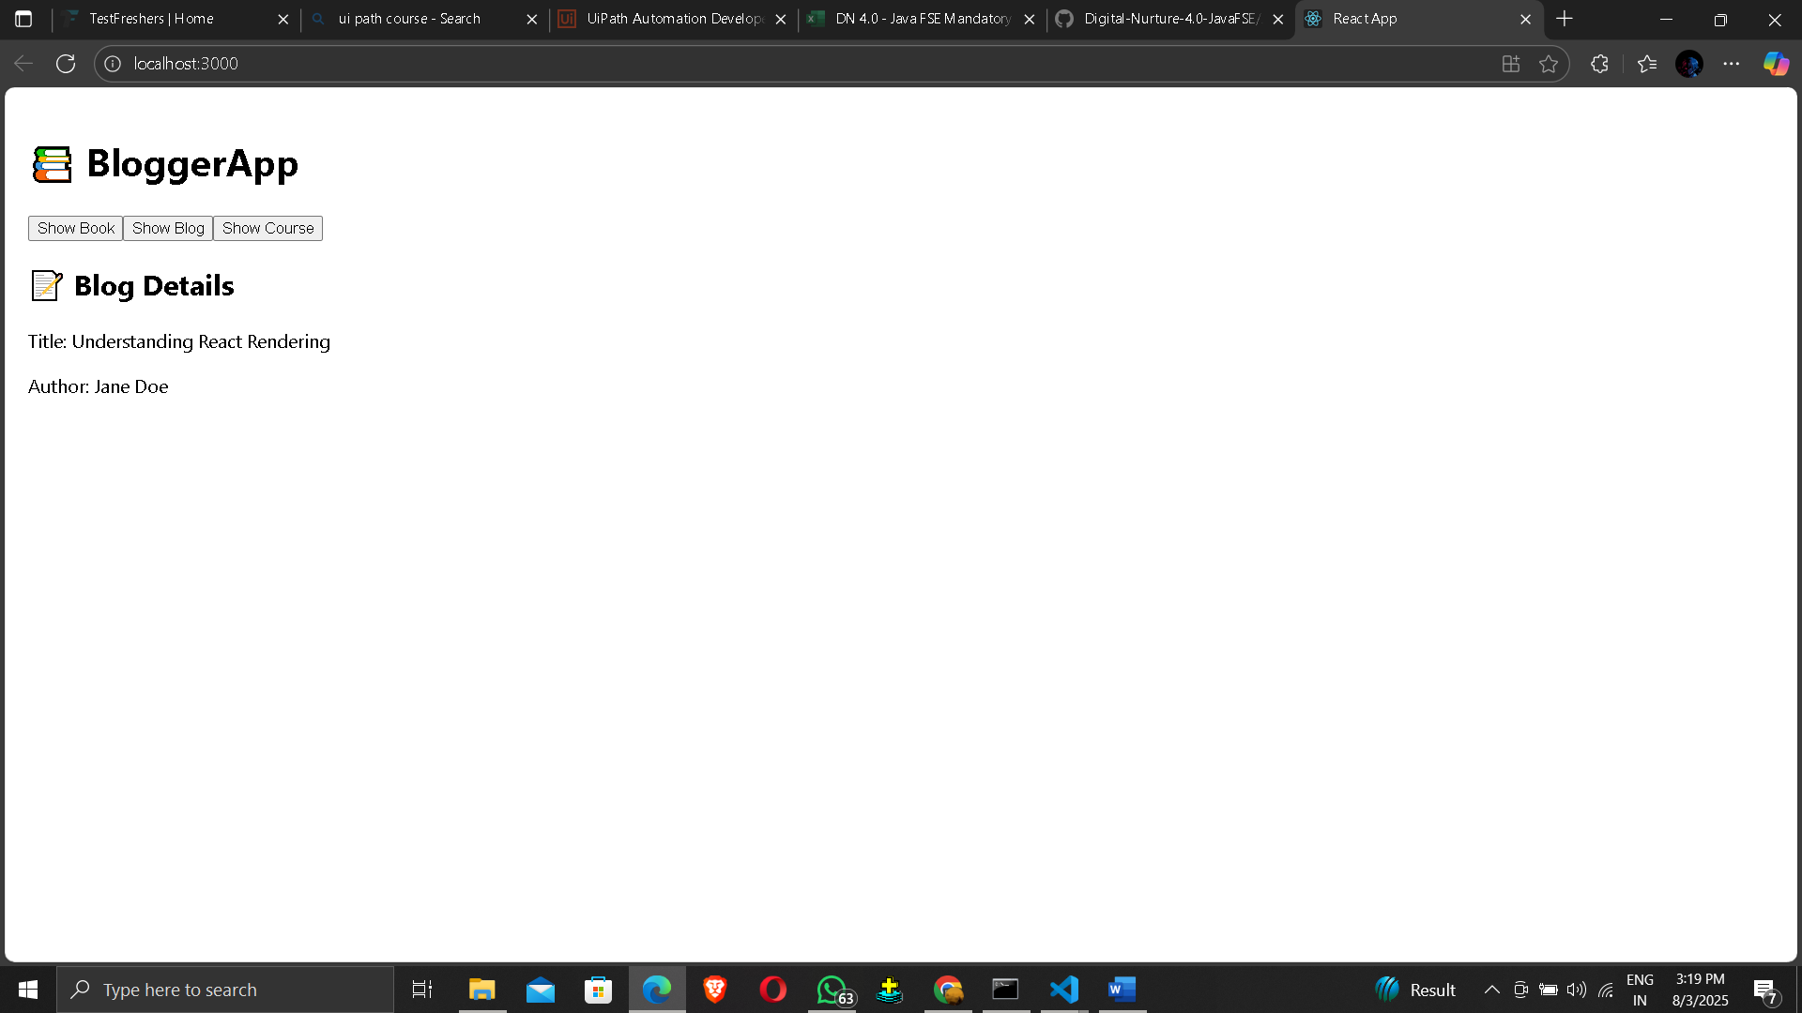
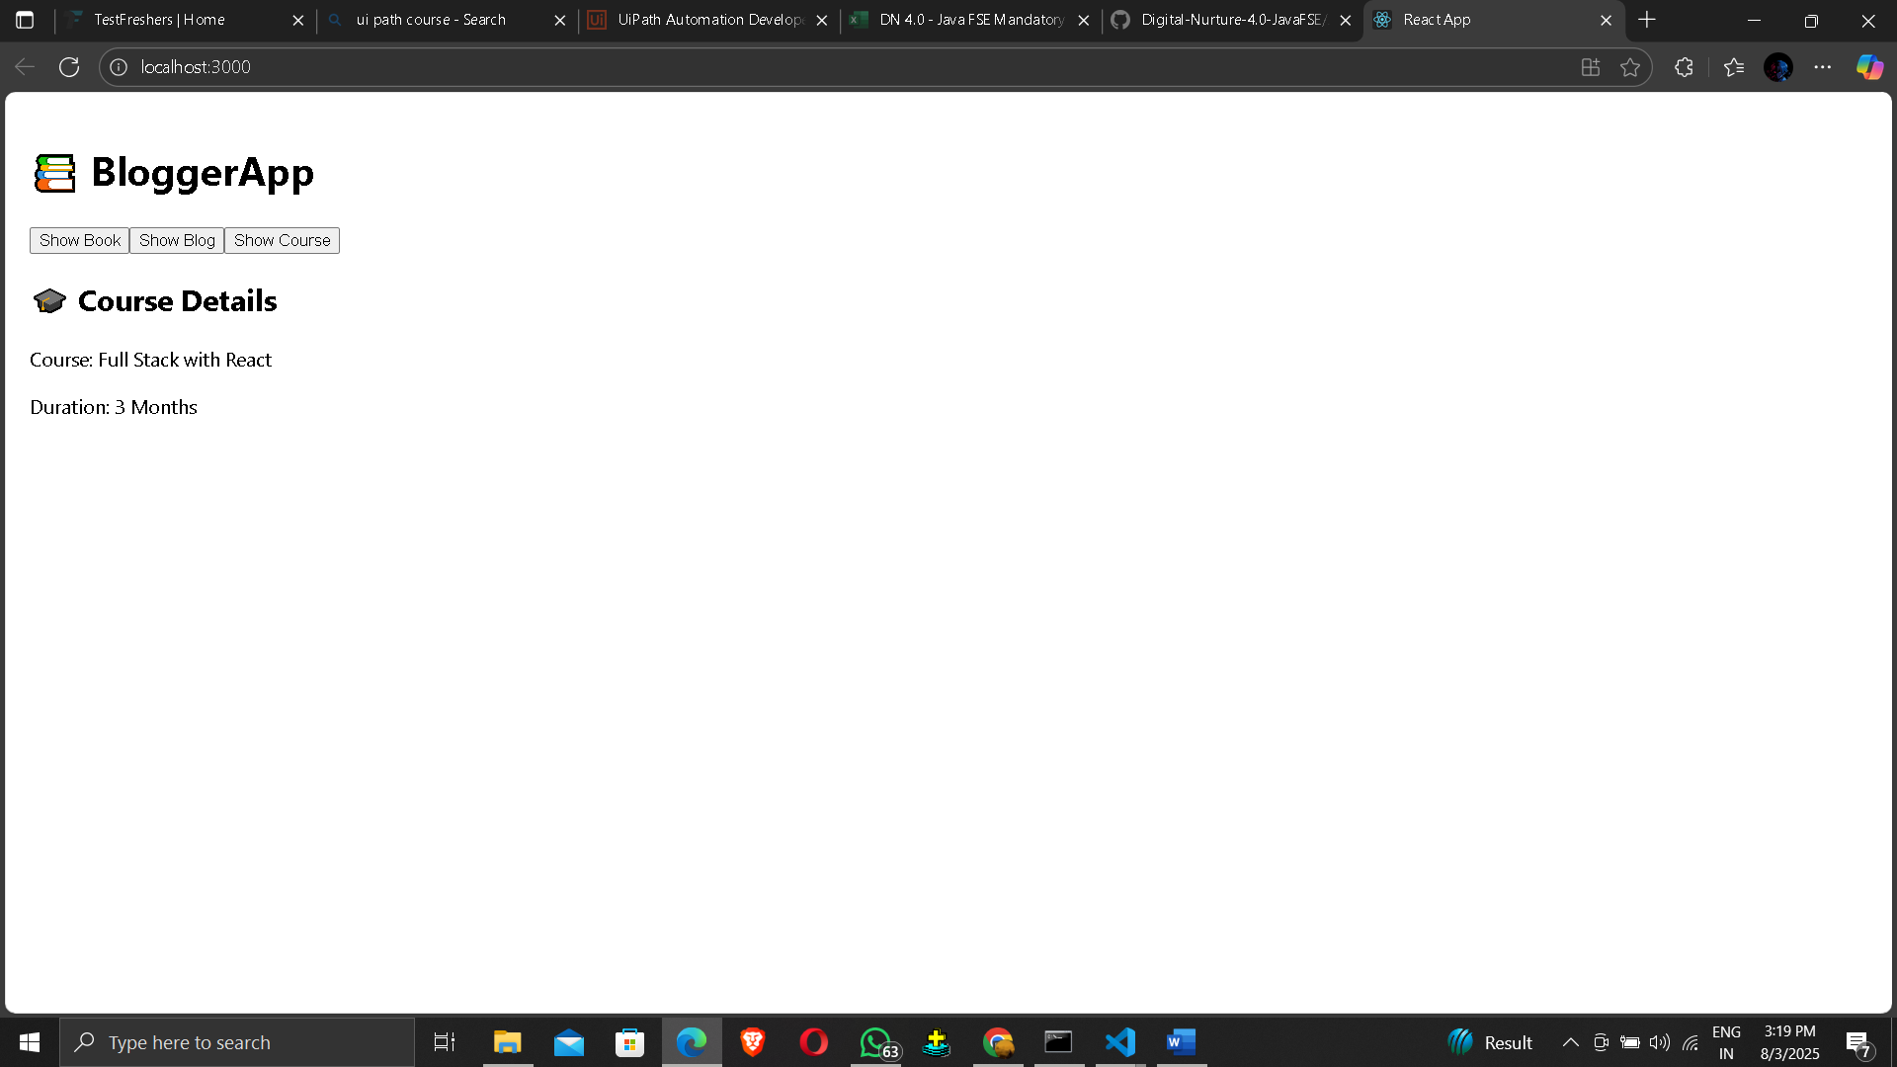

Hint:

